vfsamain_header.jpg

**THE PIPELINE**

*The Valley Forge Sewer Authority Newsletter for East Pikeland, Charlestown and Schuylkill Townships*

**Rates to Increase $10 per Quarter -Sewer Use Billing and Payment Options**

The Valley Forge Sewer Authority services about 6,800 customers within Charlestown, East Pikeland and Schuylkill townships. Quarterly service fees paid by users are the primary source of revenue to fund the conveyance and treatment of wastewater. All revenue generated from your sewer bills are used to fund operation, maintenance and replacement costs related to providing sewer service to customers. Although the Authority has not increased its rates for more than 25 years, rising cost to convey and treat wastewater supports the need to increase quarterly rates. Effective April 1, 2024, the new quarterly sewer rental rate will increase from $75.00 to $85.00. The Authority is committed to providing our customers with excellent service while keeping costs as low as possible.

Sewer use billing occurs on the first day of each calendar quarter and is due at the end of that respective month. Each quarter is paid in advance (example: January billing covers January, February and March). The Authority utilizes a flat rate billing system. The system is based on the average amount of wastewater discharged by a typical single-family residence. The single-family residence is equal to one (1) EDU (Equivalent Dwelling Unit). The current quarterly charge will increase to $85.00 per EDU effective April 1, 2024.

**The Authority is excited to announce that customers may now receive invoices by email and pay by credit card at VFSA.com. Visit the website for additional information.**

The Authority also accepts money orders and checks (both personal and business). Checks should be made payable to **Valley Forge Sewer Authority or VFSA.** If paying by mail, please include your return stub with your payment to ensure proper credit. A mail slot is located on the front door of the Administration Building if you wish to drop off your payment after the office is closed.

**Web Page**

During the past several months, the Authority has been improving its web page. This is an exciting project that we hope will enhance our communication with all our customers. The information contained on the web page includes:

Board Meeting Minutes

Newsletter Articles

Public Meeting Schedule

Sewer rental billing Procedures

Service request procedures

Office hours

Please visit our website at: [www.vfsa.com](http://www.vfsa.com)

**VFSA – SAFETY AWARDS**

Congratulations to the VFSA Staff for the following Awards for excellence of its active and effective safety program:

Pennsylvania Water Environment Association (PWEA)

Water Environment Federation (WEF)

Eastern Pennsylvania Water Pollution Control Operator's Association (EPWPCOA)

Fats, Oils, and Greases aren’t just bad for your arteries and your waistline;

They’re bad for sewers, too.

Sewer overflows and backups can cause health hazards, damage home interiors and threaten the environment. An increasingly common cause of overflows is sewer pipes blocked by grease. Grease gets into the sewer from household drains as well as from poorly maintained grease traps in restaurants and other businesses.

Where does the grease come from?

Most of us know grease is the byproduct of cooking. Grease is found in such things as:

Meat Fats

Lard

Cooking Oil

Shortening

Butter and Margarine

Food Scraps

Baking Goods

Sauces

Dairy Products

Too often, grease is washed into the plumbing system, usually through the kitchen sink. Grease sticks to the insides of sewer pipes (both on your property and in the streets). Over time, the grease can build up and block the entire pipe.

The Results can be:

Raw sewage overflowing in your home or your neighbor’s home;

An expensive and unpleasant cleanup that must be paid by you, the homeowner;

Raw sewage overflowing into parks, yards and streets;

Potential contact with disease-causing organisms; and

An increase in operation and maintenance cost for local sewer departments,

which causes higher sewer bills for customers.

What can you do to help?

The easiest way to solve the grease problem and help prevent overflows of raw sewage is to keep this material out of your sewer system in the first place. There are several ways to do this:

1. Never pour grease down the sink drain or toilets.
2. Scrape grease and food from trays, plates, pots, pans, utensils, grills and cooking surfaces

into a can or trash for disposal (or recycling where available).

1. Do not put grease down garbage disposals. Put baskets/strainers in the sink drains to catch

food scraps and other solids, and empty the drain basket/strainers into the trash for disposal.

**Disconnecting & Redirecting your Sump Pump & Downspouts**

In a community of a couple hundred homes, it only takes a few improperly connected sump pumps working in wet weather to cause a sanitary sewer backup into basements, streets, and waterways.

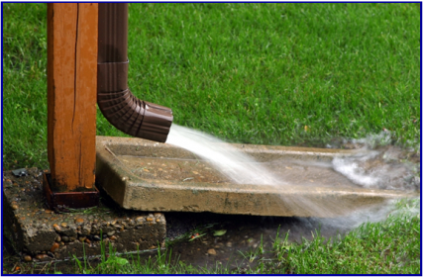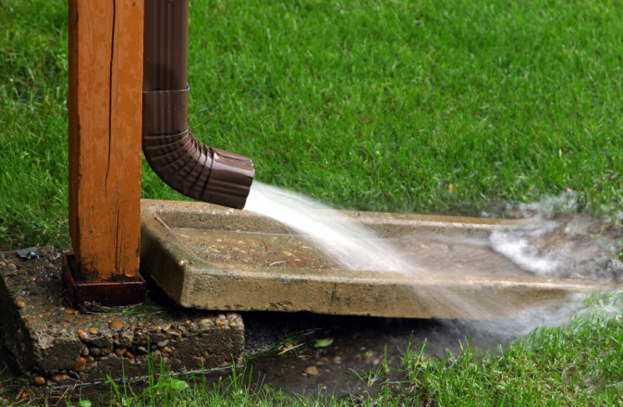

Your sump pump is most likely improperly connected to the sanitary sewer if it is connected to anything other than the drainage tile (the piping around your home’s foundation) and the discharge pipe.

**How Do I Know if my Sump Pump is Improperly Connected?**

Your sump pump is most likely improperly connected to the sanitary sewer if it is connected to anything other than the drainage tile (the piping around your home’s foundation) and the discharge pipe.

**How Do I Know if my Downspout is Improperly Connected?**

If your downspouts disappear into the ground rather than discharging into your yard, they are either connected improperly or they are connected to the storm sewer. Connections to the storm sewer are legal, only connections to the sanitary sewer must be disconnected.

**How Do I Know if my Sump Pump is Improperly Connected?**

Your sump pump is most likely improperly connected to the sanitary sewer if it is connected to anything other than the drainage tile (the piping around your home’s foundation) and the discharge pipe.

**How Do I Know if my Downspout is Improperly Connected?**

If your downspouts disappear into the ground rather than discharging into your yard, they are either connected improperly or they are connected to the storm sewer. Connections to the storm sewer are legal, only connections to the sanitary sewer must be disconnected.

**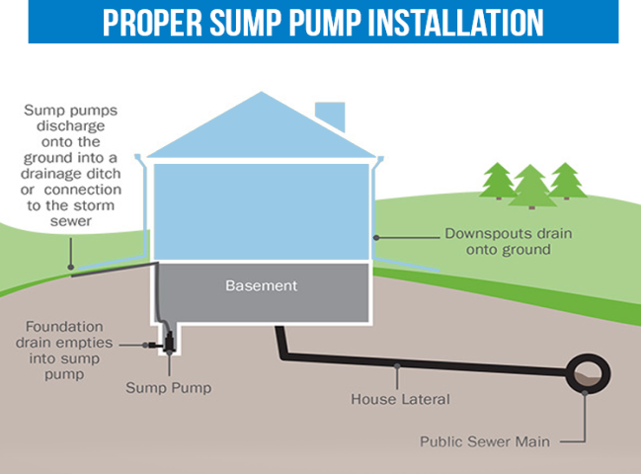**

**ump**

If your downspouts disappear into the ground rather than discharging into your yard, they are either connected improperly or they are connected to the storm sewer. Connections to the storm sewer are legal, only connections to the sanitary sewer must be disconnected.

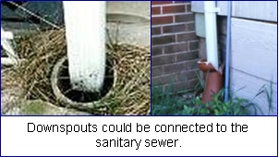

Where Should I Direct the Flow of my Disconnected Sump Pump and Downspout?

Water should be discharged away from your house or it may seep into your basement. It should flow downhill to an area where it can percolate into the ground or be stored for later use.

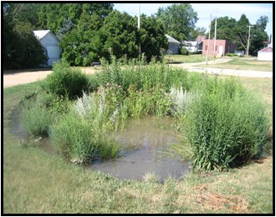 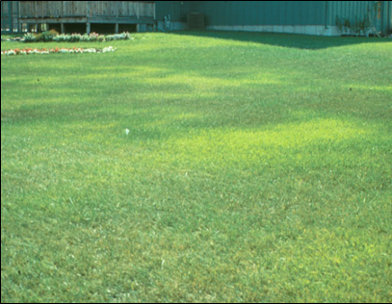 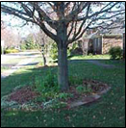 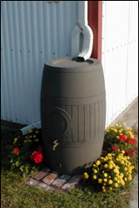

Rain Garden Lawn Trees Rain Barrel

***Never direct water onto a street, alley, right of way, easement, or neighboring property.***

**How Do I Know if my Sump Pump is Improperly Connected?**

Your sump pump is most likely improperly connected to the sanitary sewer if it is connected to anything other than the drainage tile (the piping around your home’s foundation) and the discharge pipe.

**How Do I Know if my Downspout is Improperly Connected?**

If your downspouts disappear into the ground rather than discharging into your yard, they are either connected improperly or they are connected to the storm sewer. Connections to the storm sewer are legal, only connections to the sanitary sewer must be disconnected.